**Results and Conclusions**

The robot is outlined with tall exactness in development area. In quite satisfactory manner we have achieved all the required outcomes with almost satisfactory outputs.

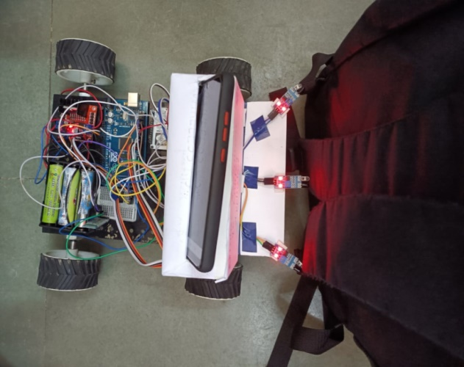

Fig 4.1(a) - obstacle is detected by the bot

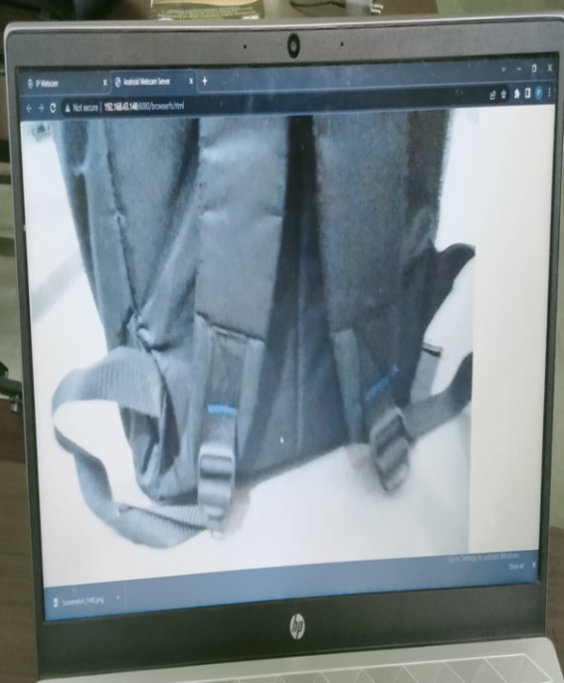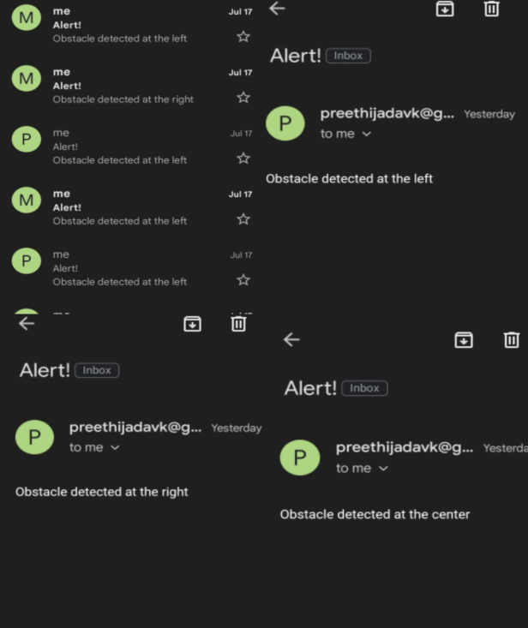

Fig 4.1(b) - alert message at control station Fig 4.1(c) - live streaming at control station

* When the obstacle is detected by using IR sensor, automatically the exact direction alert message will sent to a respective mail through a Wi-Fi module.
* At the same instant the continuous live streaming of the war field can also be done by using a camera which can be displayed at control station through IP web cam.
* At this time the bot will stops and start to move in backward direction up to 2secs of time.
* Later the bot is controlled manually by giving a commands like Right, Left, Forward and Reverse by using Bluetooth paired app of which the Bluetooth module is paired.

When the obstacle is not detected the bot will continuous to move as per the instructions.

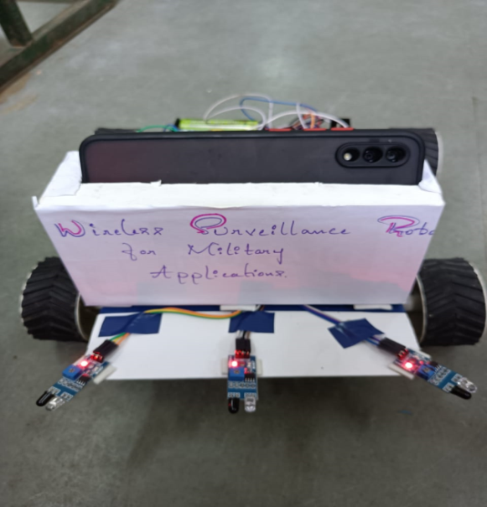

Fig 4.2(a)-Moving bot in absence of obstacle

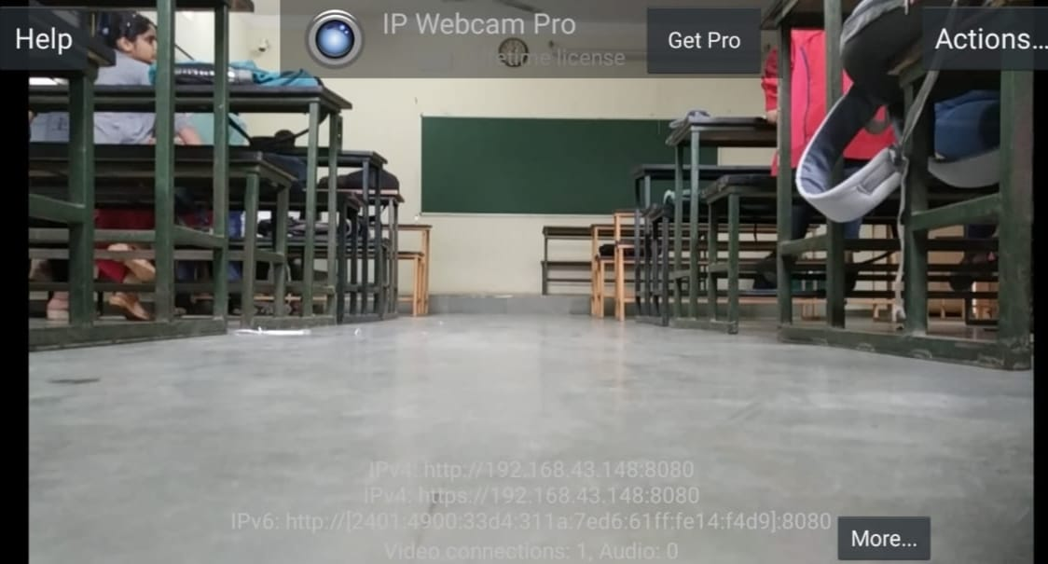

Fig 4.2(b)- live stream processing at IP Web cam

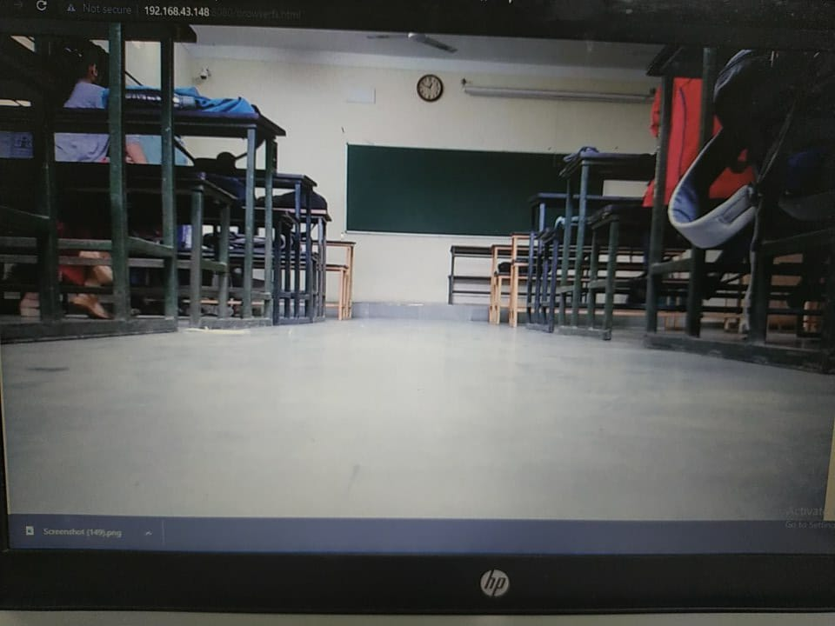

Fig 4.2(c)- result of live streaming at control station